Supplies
- Griess Reagent System (Promega G2930)
- Culture media for particular cell used
- 96-well plate (not tissue culture treated. Use a UV transparent plate)
- Blank 96-well grid fill-in sheet for labeling wells
- Multichannel pipettor
- 10-100 uL pippetor
- Yellow tips
- Pipet basins (3)
- Cells grown in 96-well plate for at least 12 hours

Procedure
- Before preparing the standard, that out the Sulfanilamide Solution (SS) and NED solution to equilibrate to room temperature.

Standard Curve (Prepare EACH time for EACH plate)
- Prepare 1 mL of a 100 uM nitrate solution by diluting the provided 0.1 M nitrite standard (1:1,000) in cell culture media. A 1:1,000 solution is made by adding 1 uL of standard to 1 mL of media.
- Designate 3 columns (24 wells) in a 96-well plate for the nitrite standard reference curve.
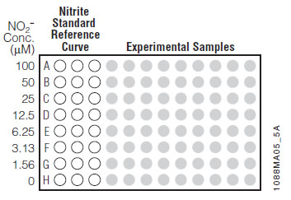
4. Add 50 uL of media to wells B-H in row 1-3. 5. Ad d 100 uL of 100 uM nitrite solution (prepared above) to wells row A col. 1-3.
6. Using a multichannel pippetor with three tips, take 50 uL of the 100 uM solution out of the wells in row A and place them in row B col. 1-3.
7.Carefully pipet up and down to mix. About 5 times. Try to minimize bubbles by releasing and taking up the pipet under the surface of the media.
8. Make twofold serial dilutions (as above, 50 ul from above well into below well) until row G. When you are done mixing the standards in row G, discard the remaining 50 uL and DO NOT put them into row H. Row H should have the zero samples and should not contain nitrite solution. The standards should be in the concentrations indicated above in the picture. Each well should only contain 50 uL and the liquid should be the same height in the well.

Experimental
- In the remaining rows and columns of the plate add 50 uL of the supernatant from each of your wells. Ensure a new tip is used for each sample to prevent contamination between samples.
- Dispense SS into a pipet basin at a volume relevant to your work. (roughly: 50 uL * # of samples + 1.5 mL [Standards] + 0.5 mL [extra volume]). Refer to table for ease of calculation.

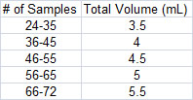

- With multichannel pipet add 50 uL of SS to each well, including standards and experimental. When using the multichannel pipet make sure the height of the media in tips is equal across all tips and that bubbles are absent. Any change in volume will change the absorbance readings, per Beer’s law.
- Incubate 5-10 minutes at room temperature. Protect the plate from light by wrapping in aluminum foil.
- Using a multichannel pipet (with fresh tips) and a new pipet basin filled with NED solution at the same volume as SS solution, pipet 50 uL of NED into each well of the plate.
- Incubate at room temperature protected from light (in Al foil) for 5-10 minutes. A purple/magenta color will begin to form immediately.
- Measure absorbance within 30 minutes in a plate reader with a filter between 520 nm and 550 nm.

Troubleshooting
- Color will fade after 30 minutes
- If you are collecting time points, the NO will degrade even if frozen. Schedule experiments to end at the same time in order to best run the assay.

