**Title**: Chemiluminescence

**Age Group**: 6th-12th

**Type:** Stage Show - Energy Show

Abstract

In a darkened room, a colorless liquid and a blue liquid are pumped into a clear tube. Upon mixing, the solutions glow blue and spell out the words Science Lions. Once the light turns on, the solutions appear to look like ginger ale.

**Supplies:**

Luminol Solution:

* 500 ml distilled water
* 2.0 g sodium carbonate
* 12.0 g sodium bicarbonate
* 0.25 g ammonium carbonate
* 0.2 g copper (II) sulfate pentahydrate
* 0.1 g luminol

Oxidizing Solution:

* 25 ml of 3% hydrogen peroxide
* 500 ml distilled water

Two amber 1 liter bottles

Science Lions sign

Peristaltic pump

2 125 mL flasks

1 500 mL flask

500 ml water

**Preparation:**

Chemiluminescence solutions can be made and stored separately in amber bottles or aluminum foil wrapped clear bottles for about 6 months

Luminol Solution:

In a 1 liter amber bottle, dissolve 2.0 g of sodium carbonate in 500 ml of distilled water. Add 0.1 gm of luminol and stir to dissolve. The luminol can sometimes be tricky to dissolve. Heating is not suggested to induce mixing. Add 12 g of sodium bicarbonate, 0.25 g of ammonium carbonate monohydrate, and 0.2 g of copper (II) sulfate pentahydrate and stir until all the solids dissolve. Place lid on securely and store until time of use.

Oxidizing solution

Place 25 ml of 3% hydrogen peroxide (drug store quality) into a 1 liter amber bottle. Add 500 ml of distilled water. Store until time of use, can be stored at

room temperature. For optimum storage, keep in refrigerator.

Test solutions prior to use by mixing equal parts of each in a beaker.

**Description:**

Prerequisites

Students should be familiar with the following things prior to the experiment so they can better understand the concepts covered in this demonstration.

1. The concept of atoms and molecules
2. Energy is stored in chemical bonds
3. The concept of a chemical reaction, i.e., reactants and products
4. The idea of energy, to know what is energy, or at least examples of energy

Objectives

* + Energy from chemical bonds can be released as light
  + The concept of a catalyst
  + Understand activation energy and how a catalyst effects it

Vocabulary

*Chemical Bonds* – interaction between two atoms. Energy is used to create, so stored potential energy is present in the bond. In particular we are discussing covalent bonds which are the strongest type of chemical bonds and involves the interaction of electrons.

*Potential Energy* – Simply stored energy

*Exothermic Reactions* – Reactions that give energy to the surroundings in the form of heat, light, and sound.

*Activation Energy –*[the](http://www.hyperdictionary.com/dictionary/the) [energy](http://www.hyperdictionary.com/dictionary/energy) [that](http://www.hyperdictionary.com/dictionary/that) [an](http://www.hyperdictionary.com/dictionary/an) [atomic](http://www.hyperdictionary.com/dictionary/atomic) [system](http://www.hyperdictionary.com/dictionary/system) [must](http://www.hyperdictionary.com/dictionary/must) [acquire](http://www.hyperdictionary.com/dictionary/acquire) [before](http://www.hyperdictionary.com/dictionary/before) [a](http://www.hyperdictionary.com/dictionary/a) [process](http://www.hyperdictionary.com/dictionary/process) ([such](http://www.hyperdictionary.com/dictionary/such) [as](http://www.hyperdictionary.com/dictionary/as) [an](http://www.hyperdictionary.com/dictionary/an) [emission](http://www.hyperdictionary.com/dictionary/emission) [or](http://www.hyperdictionary.com/dictionary/or) [reaction](http://www.hyperdictionary.com/dictionary/reaction)) [can](http://www.hyperdictionary.com/dictionary/can) [occur](http://www.hyperdictionary.com/dictionary/occur).

*Chemiluminescence –* luminescence resulting from a chemical reaction

*Oxidation -* Any reaction which removes electrons from a molecule or atom. LEO says GER - loss of electrons oxidation and gain in electrons reduction.

*Protic Solvent-*a solvent in which a hydrogen is bonded to a strongly electronegative element such as oxygen or nitrogen. A protic solvents tend to make an acid dissociate more easily.

*Oxidant -* A molecule or atom that accepts electrons in an oxidation-reduction reaction. The substance that oxidizes another substance.

*Ion –*­ A charged particle. An atom or molecule that has lost or gained electrons.

*Aqueous –* in water

*Intermediate –* in a chemical reaction, usually refers to a species that exists only momentarily before it reacts.

*Diainion –* double anion. Contains two negative charges; has lost two electrons in different places.

*Transition metal –* a metal that composes the middle part of the periodic table indicated as a metal with in the bracketed area that says transition elements.

*Anion –* A negatively charge ion.

*Superoxide anion –* Diatomic oxygen (O2) with a negative charge

*Catalyst –* A substance that initiates a chemical reaction without being used up. Typically lessens the activation energy of that reaction by perhaps causing another reaction to occur.

*Activators –* used in this context to be identical to catalyst

*Quanta* - The fundamental unit of electromagnetic energy

*Quantum Yield* – or quantum efficiency, is defined as the ratio of the number of molecules reacted or produced to the number of quanta absorbed. Molecules that have a quantum yield of zero absorb visible or ultraviolet radiation. Quantum yield on the order of 106 show no photochemical reaction.

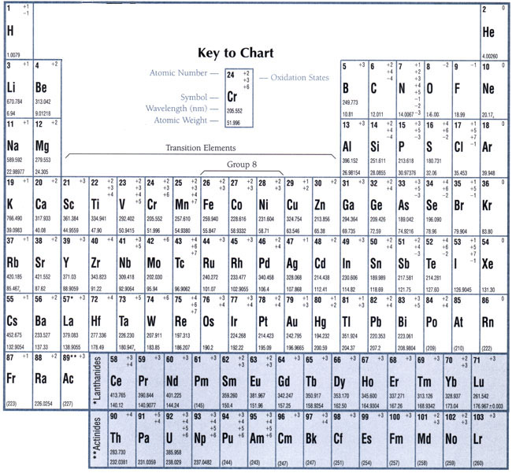

Abstract

In a darkened room, a colorless liquid and a blue liquid are pumped into a clear tube. Upon mixing, the solutions glow blue and spell out the words Science Lions. Once the light turns on, the solutions appear to look like ginger ale.

How to

1. Prior to show, load pump with sign effluent tubing. Keep enough tubing to place securely in disposal flask.
2. At time of demonstration, turn room lights off. Pour each of the solutions into separate flasks. Place inlet ends of tubing into solutions.
3. Turn on pump and keep around 1 or 2.
4. Stop pump when solution get to pump inlet.
5. Let glow for some time
6. Turn on room lights
7. Clean right after show with by pumping through water

Explanation

This reaction has two aspects which on could talk about. 1) is a catalyst reaction and 2) that light is being produced.

A catalyst is something that makes the reaction happen, but is not used up in the reaction. What happens with this reaction is that the catalyst reduces the activation energy of the reaction. By reducing the activation energy, it makes it much easier for the reaction to take place because it requires less energy to get going. It is like waking up in the morning. The way you wake up now, would be like you didn’t have a catalyst. If you slept with your bed at a 90 degree angle, it would be much simpler to get out of it, right?



Exothermic

With Catalyst

Endothermic





Activation

Energy

Activation

Energy

With Catalyst

R

P

P

R

E

N

E

R

G

Y

Reaction Progress

Reaction Progress

E

N

E

R

G

Y

This is the reaction going on:

luminol + 2 OH- oxidized luminol + 2 H2O + N2+ Energy

Cu2+

Where else have you seen a reaction like this? How about something in nature? This is the type of chemistry that happens in the butt of a fire. Phosphorous causes the yellow color.

Just like with the firefly, this reaction releases energy in the form of light. It glows blue because of the copper catalyst.

**Safety:**

The solutions should never be drunk. Solutions can be washed down the sink with copious amounts of water.

**Technical:**

One of the most well-known examples of chemiluminescence is that of luminol (3-aminophthalhydrazide or 5-amino-2,3-dihydrophthalazine-1,4-dione). Compound I:

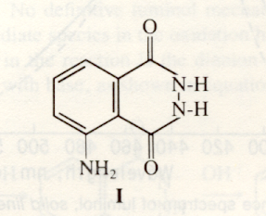

The bright blue emission produced by Chemiluminescence reactions of luminol is readily visible in a darkened room. By increasing the surface area of the reaction, such as piping it through tubing, allows an entire room to witness the reaction.

The chemiluminescent reactions of luminol are all oxidations (7), as represented by equation 1:

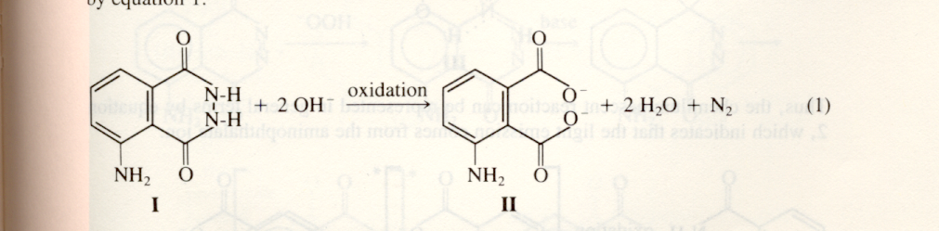

The reaction can be carried out in a variety of media including protic solvents such as water or an alcohol. The reaction mechanism varies with the solvent. Different oxidants are required and slightly different chemiluminescent spectra are observed in different media. The emitting species in any media has been identified as a form of the product aminophthalate in II. This identification is made on the basis of the correspondence between the chemiluminescent spectrum of luminol and the fluorescent spectrum of the aminophthalate ion. As shown in figure 2, the fluorescent spectrum of the aminophthalate ion in water and the spectrum of the chemiluminescence from the aqueous oxidation of luminal are superimposable (White).

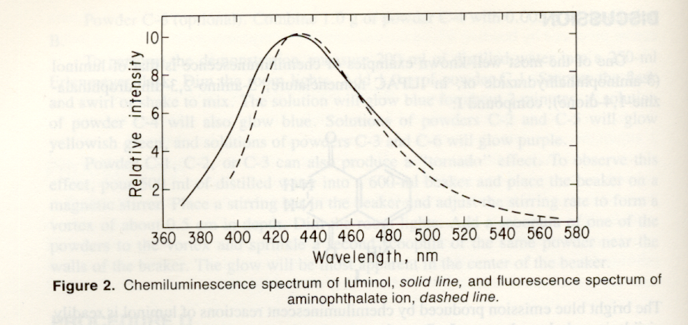

Thus, the chemiluminescent reaction can be represented in general terms by equation 2, which indicates that the light emission comes from the aminophthalate ion:

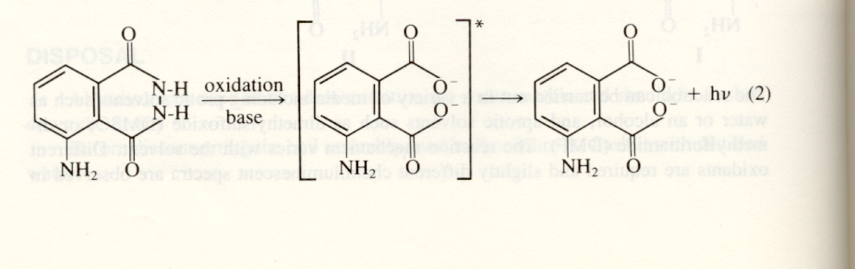

Considerable data have been accumulated on the mechanism of the oxidation of luminol. No definitive luminol mechanism is known, but much information about the intermediate species in the oxidation has been gathered (Rosewell).

An important intermediate in the reaction is the dianion of luminol, IV, which is formed in a stepwise reaction with base, show in equation 3.

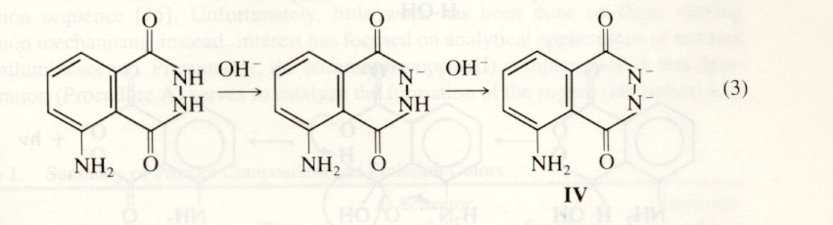

The most recent proposed mechanism is constructed around this dianion, which may undergo several different reactions (Rosewell). One of these is the formation of an azaquinone, V, as represented in equation 4 (Gunderman).

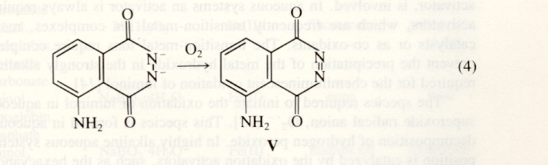

Azaquine is believed to be an intermediate in the light-producing pathway in the oxidation of luminol (McCapra & Merenyi). One such pathway, proposed by White (White), is outlined below:

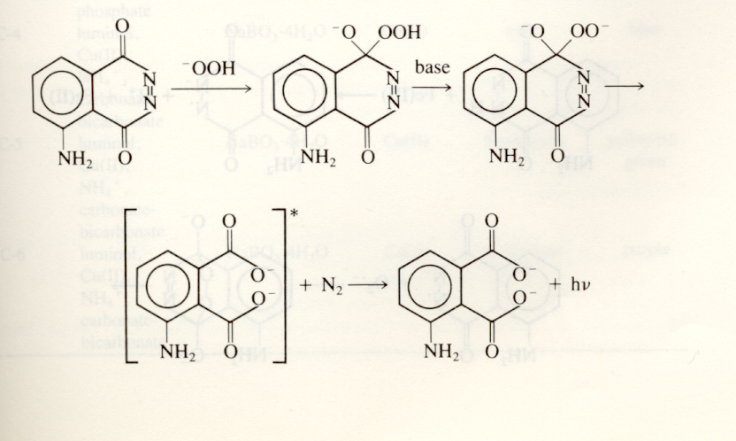

Another mechanism, suggested by McCapra (McCapra), is based on electron transfer and involved the loss of nitrogen gas much earlier in the reaction than does White’s mechanism:

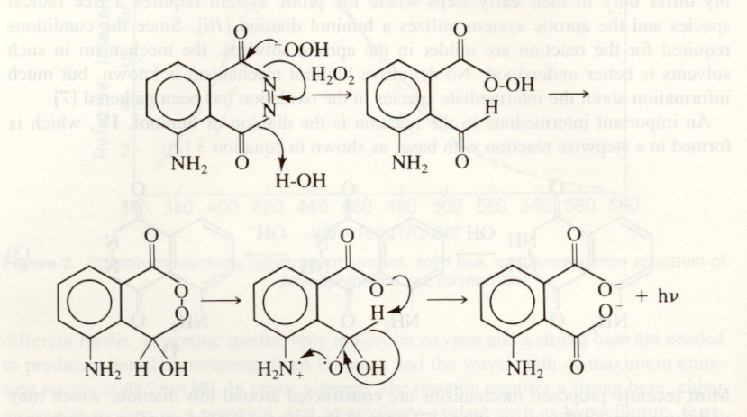

In aqueous systems, an activator is always required (White). These activators, which are frequently transition-metals ion complexes, may act either as catalysts or as co-oxidants. The transition-metal ions require complexing agents to prevent the precipitation of metal hydroxide in the strongly alkaline environment required for the chemiluminescent oxidation of luminol (White).

The species required to initiate the oxidation of luminol in aqueous media is the superoxide radical anion, O2• - (Merenyi). This species is formed in aqueous media by the decomposition of hydrogen peroxide. In highly alkaline aqueous systems, this decomposition is catalyzed by the oxidation activators, such as tetramminecopper (II) or hexacycanoferrate (III) ion (White). In our procedure, the tertamminecopper (II) complex would replace the work of the hexacycanoferrate (III) ion complex depicted below:

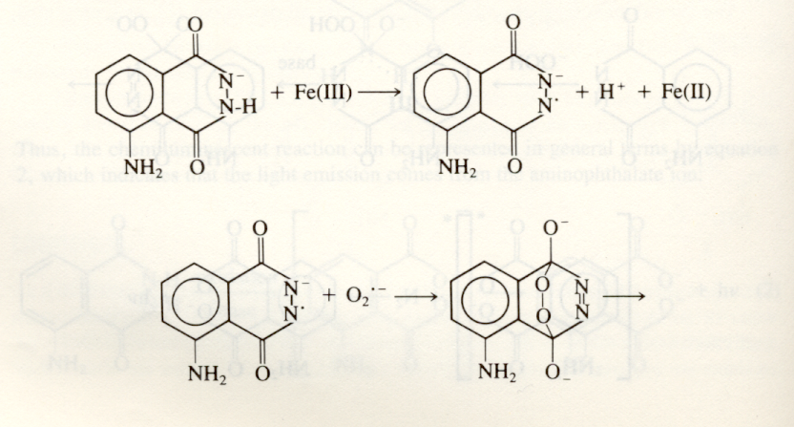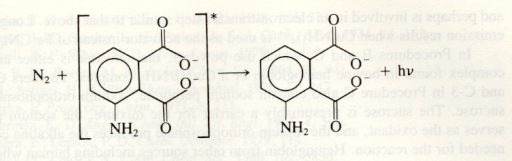

The transitions-metal complex ions may also be involved in an electron-transfer step in the oxidation of luminol (Hodgson).

The chemiluminescent quantum yield of luminol oxidation reactions depends on several factors, including the solvent and the pH of the mixture (Seliger & Lee). Table 2 illustrates the effects of these factors. The reaction is most efficient in producing light in aqueous media with a pH of 11 (Seliger); at that pH level, the efficiency reaches 2%. Although the reaction is most efficient at a pH of 11, its apparent brightness reaches a maximum at a pH of about 9 using Cu(II) as the activator. In the aqueous oxidation of luminol, hydroxide ions are consumed, as shown in equation 1. To yield maximum brightness, a carbonate buffer is used to maintain a pH around 9.

|  |  |
| --- | --- |
| Water (pH) | Quantum Yield (c) |
| 9.6 | 0.01 |
| 11 | 0.02 |
| 12 | 0.01 |
| 13 | 0.006 |
| 14 | 0.002 |
| 15 | 0.0004 |

Table 2. Quantum Yields of Luminol Oxidations in water (Seliger & Lee)

# References

1. B.Z. Shakhashiri. “Chemical Demonstrations,”. University of Wisconsin Press: Madison, 1983; Vol. 1, pp 156-167. Text taken directly from this source.
2. Rosewell, D.F.; White, E.H. *Meth. Enzyme.* 1978, 57, 409.
3. Gunderman, K.D. *Agnew. Chem. Intl. Ed. Engl.* 1965, 4, 566.
4. McCapra, F; Leeson, P.D. *Chem. Commun.* **1979**, 114.
5. Merenyi, G; Lind, J.S. *J. Am. Chem. Soc.* 1980, 102,5830.
6. White, E.H. in “Light and Life,” McElroy, W.D.; Glass, B., Eds.; Johns Hopkins Press: Baltimore, MD, 1961; p 200.
7. Lee, J.; Seliger, H.H. *Photochem. Photobiol.* **1972,** 15, 227.